**Project Guide**

1. **User Guide**

This user guide will assist the users to run the system more effectively and efficiently. ‘Agent and Marketer’ web application has the 3 different panels and one front view for all users.

* **Agent Panel:** agent can perform operations like upload documents, ask queries and take response from queries, the menu options are:

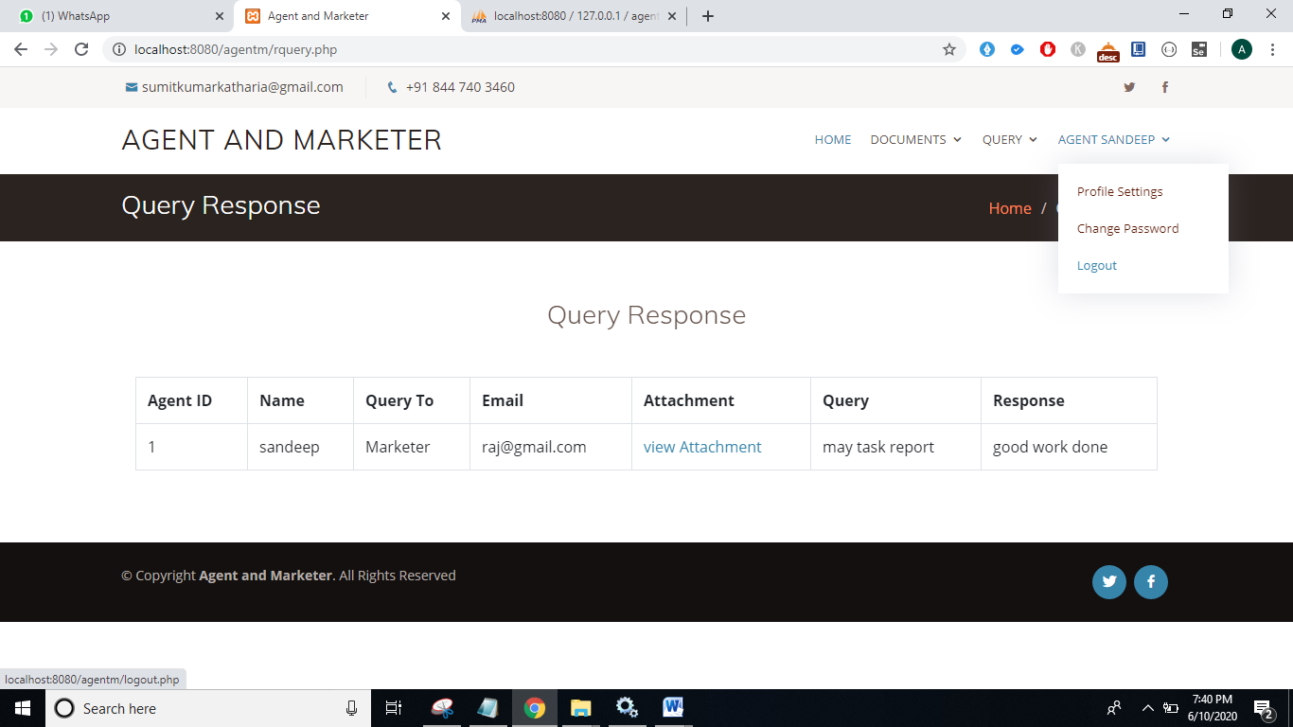

* **Marketer Panel:** Marketers need to enter valid credentials and thereafter can perform actions like view linked agents, view uploaded documents, response queries and update profile details.

The menu options are:

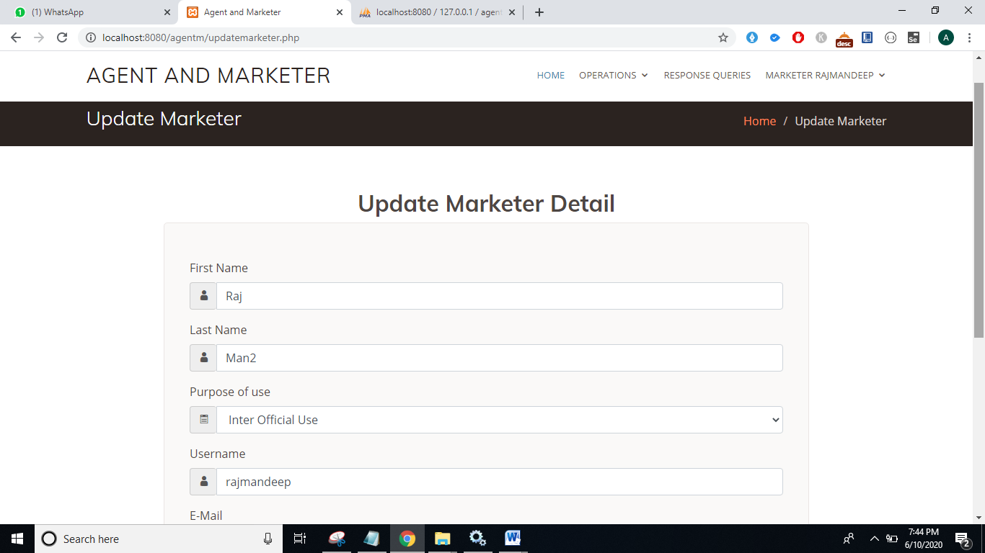

* **Admin Panel:** admin panel has the complete rights to view all marketers and agent details, The menu options are:

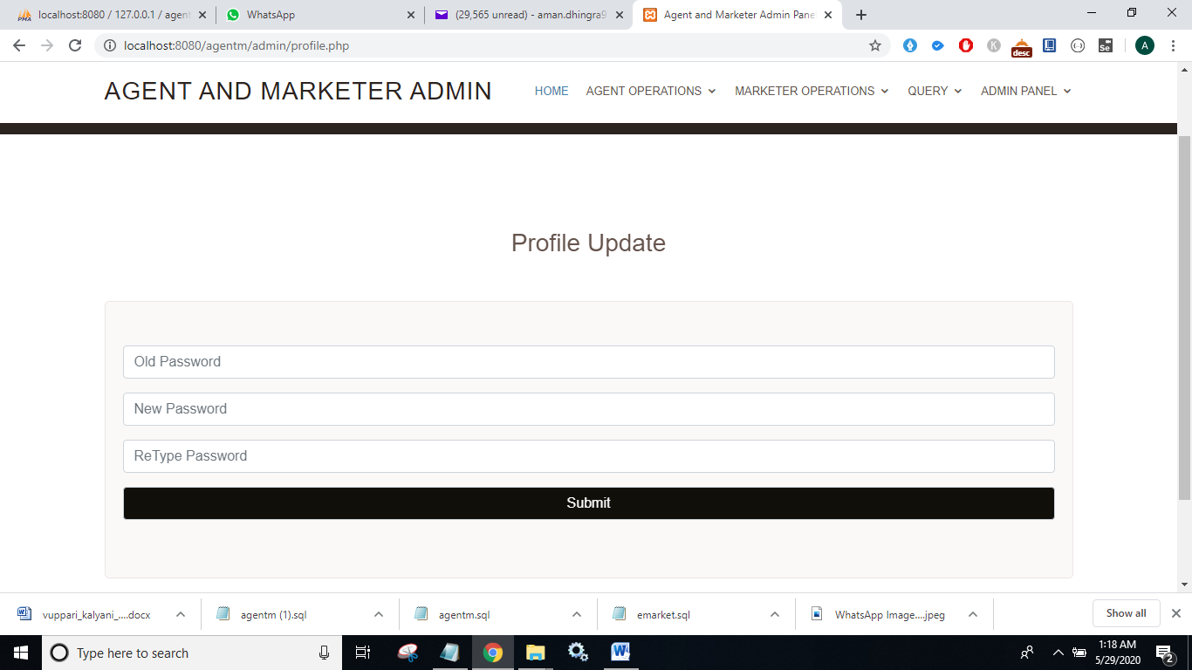

* **All Users:** All users and visitors can see the details like agent, marketer login web page, about project and contact web form. The menu options are:

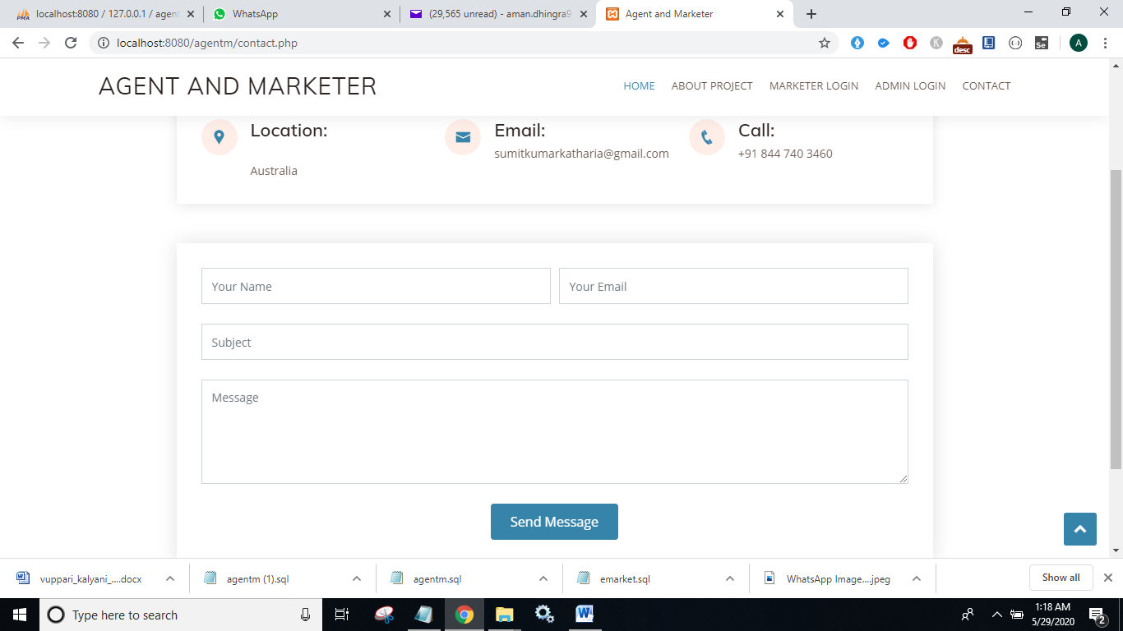

1. **Git hub access- login**

* **User name or email address -** [sandydhiman01@gmail.com](mailto:sandydhiman01@gmail.com)
* **Password –** nagrasandeep6666
* **Email –** sandydhiman01@gmail.com

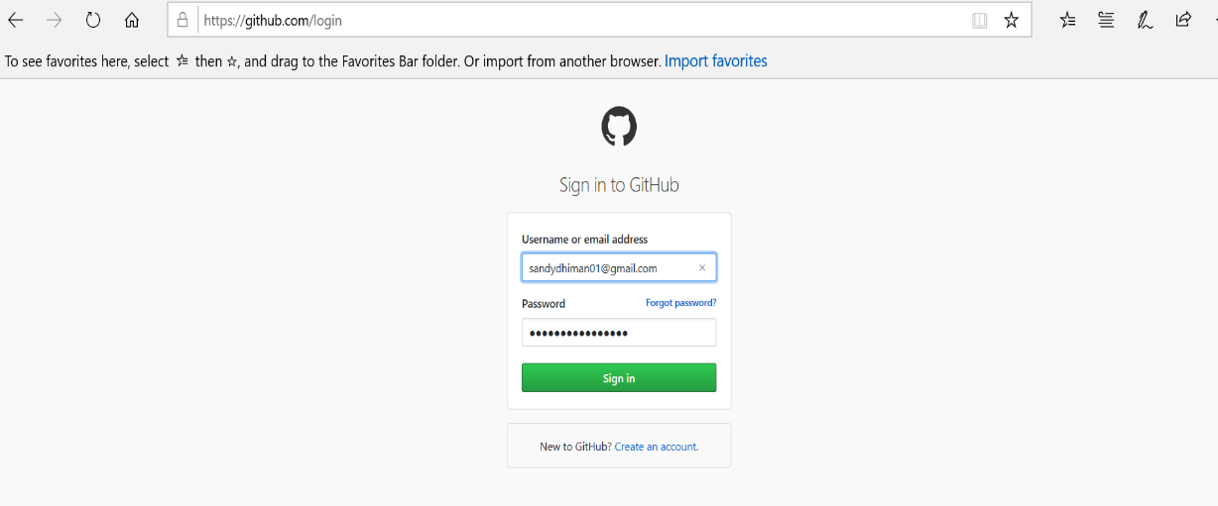

1. **Deployment Guide**

The following steps are followed to deploy the project on local machine server.

1. To run php web applications, need to download XAMPP Server and install it on local machine.
2. Open the drive where you have installed XAMPP and go to htdocs folder.
3. Download the source code file folder from the provided github link:-

https://github.com/sandeepkaurnagra/AGENT-and-MARKETER

1. Paste it in htdocs folder.
2. Run XAMPP control panel and start apache, mysql services.
3. Open localhost/phpmyadmin/ in web browser and import provided agentm.sql file.
4. Write localhost/agentm/ in web browser and following index page will be shown:-

Agent and marketer- HOME page

